Microsoft Windows [Version 10.0.19045.4651]
(c) Microsoft Corporation. All rights reserved.

C:\WINDOWS\system32>list disk
'list' is not recognized as an internal or external command,
operable program or batch file.

C:\WINDOWS\system32>select disk <disk number>
The syntax of the command is incorrect.

C:\WINDOWS\system32>list partition
'list' is not recognized as an internal or external command,
operable program or batch file.

C:\WINDOWS\system32>select partition <partition number>
The syntax of the command is incorrect.

C:\WINDOWS\system32>attributes disk clear readonly
'attributes' is not recognized as an internal or external command,
operable program or batch file.

C:\WINDOWS\system32>wmic volume list brief
'wmic' is not recognized as an internal or external command,
operable program or batch file.

diskpart
C:\WINDOWS\system32>diskpart

Microsoft DiskPart version 10.0.19041.3636

Copyright (C) Microsoft Corporation.
On computer: DESKTOP-RFICS5J

DISKPART> list disk

Disk ### Status Size Free Dyn Gpt
-------- ------------- ------- ------- --- ---
Disk 0 Online 931 GB 0 B *
Disk 1 Online 238 GB 1024 KB *

DISKPART> select disk <Disk 1>

The arguments specified for this command are not valid.
For more information on the command type: HELP SELECT DISK

There is no disk selected.

DISKPART> select disk <1>

The disk you specified is not valid.

There is no disk selected.

DISKPART> select disk 1

Disk 1 is now the selected disk.

DISKPART> list partition

Partition ### Type Size Offset
------------- ---------------- ------- -------
Partition 1 System 680 MB 1024 KB
Partition 2 Reserved 128 MB 681 MB
Partition 3 Primary 217 GB 809 MB
Partition 4 Recovery 990 MB 218 GB
Partition 5 Recovery 17 GB 219 GB
Partition 6 Recovery 1304 MB 237 GB

DISKPART> select partition 5

Partition 5 is now the selected partition.

DISKPART> delete partition override

DiskPart successfully deleted the selected partition.

DISKPART> list partition

Partition ### Type Size Offset
------------- ---------------- ------- -------
Partition 1 System 680 MB 1024 KB
Partition 2 Reserved 128 MB 681 MB
Partition 3 Primary 217 GB 809 MB
Partition 4 Recovery 990 MB 218 GB
Partition 6 Recovery 1304 MB 237 GB

DISKPART> select partition 6

Partition 6 is now the selected partition.

DISKPART> delete partition override

DiskPart successfully deleted the selected partition.

DISKPART> list partition

Partition ### Type Size Offset
------------- ---------------- ------- -------
Partition 1 System 680 MB 1024 KB
Partition 2 Reserved 128 MB 681 MB
Partition 3 Primary 217 GB 809 MB
Partition 4 Recovery 990 MB 218 GB

DISKPART> reagentc / info

Microsoft DiskPart version 10.0.19041.3636

ACTIVE - Mark the selected partition as active.
ADD - Add a mirror to a simple volume.
ASSIGN - Assign a drive letter or mount point to the selected volume.
ATTRIBUTES - Manipulate volume or disk attributes.
ATTACH - Attaches a virtual disk file.
AUTOMOUNT - Enable and disable automatic mounting of basic volumes.
BREAK - Break a mirror set.
CLEAN - Clear the configuration information, or all information, off the
disk.
COMPACT - Attempts to reduce the physical size of the file.
CONVERT - Convert between different disk formats.
CREATE - Create a volume, partition or virtual disk.
DELETE - Delete an object.
DETAIL - Provide details about an object.
DETACH - Detaches a virtual disk file.
EXIT - Exit DiskPart.
EXTEND - Extend a volume.
EXPAND - Expands the maximum size available on a virtual disk.
FILESYSTEMS - Display current and supported file systems on the volume.
FORMAT - Format the volume or partition.
GPT - Assign attributes to the selected GPT partition.
HELP - Display a list of commands.
IMPORT - Import a disk group.
INACTIVE - Mark the selected partition as inactive.
LIST - Display a list of objects.
MERGE - Merges a child disk with its parents.
ONLINE - Online an object that is currently marked as offline.
OFFLINE - Offline an object that is currently marked as online.
RECOVER - Refreshes the state of all disks in the selected pack.
Attempts recovery on disks in the invalid pack, and
resynchronizes mirrored volumes and RAID5 volumes
that have stale plex or parity data.
REM - Does nothing. This is used to comment scripts.
REMOVE - Remove a drive letter or mount point assignment.
REPAIR - Repair a RAID-5 volume with a failed member.
RESCAN - Rescan the computer looking for disks and volumes.
RETAIN - Place a retained partition under a simple volume.
SAN - Display or set the SAN policy for the currently booted OS.
SELECT - Shift the focus to an object.
SETID - Change the partition type.
SHRINK - Reduce the size of the selected volume.
UNIQUEID - Displays or sets the GUID partition table (GPT) identifier or
master boot record (MBR) signature of a disk.

DISKPART> uniqueid disk 4

The arguments specified for this command are not valid.
For more information on the command type: HELP UNIQUEID DISK

DISKPART> uniqueid partition 4

Microsoft DiskPart version 10.0.19041.3636

DISK - Displays or sets the GUID partition table (GPT) identifier or
master boot record (MBR) signature of a disk.

DISKPART> list partition

Partition ### Type Size Offset
------------- ---------------- ------- -------
Partition 1 System 680 MB 1024 KB
Partition 2 Reserved 128 MB 681 MB
Partition 3 Primary 217 GB 809 MB
Partition 4 Recovery 990 MB 218 GB

DISKPART> list disk

Disk ### Status Size Free Dyn Gpt
-------- ------------- ------- ------- --- ---
Disk 0 Online 931 GB 0 B *
* Disk 1 Online 238 GB 18 GB *

DISKPART> select disk 0

Disk 0 is now the selected disk.

DISKPART> list partition

Partition ### Type Size Offset
------------- ---------------- ------- -------
Partition 1 Reserved 128 MB 1024 KB
Partition 2 Primary 931 GB 129 MB

Calculated D: shrink volume available (922GB)
and shrink volume (200GB)
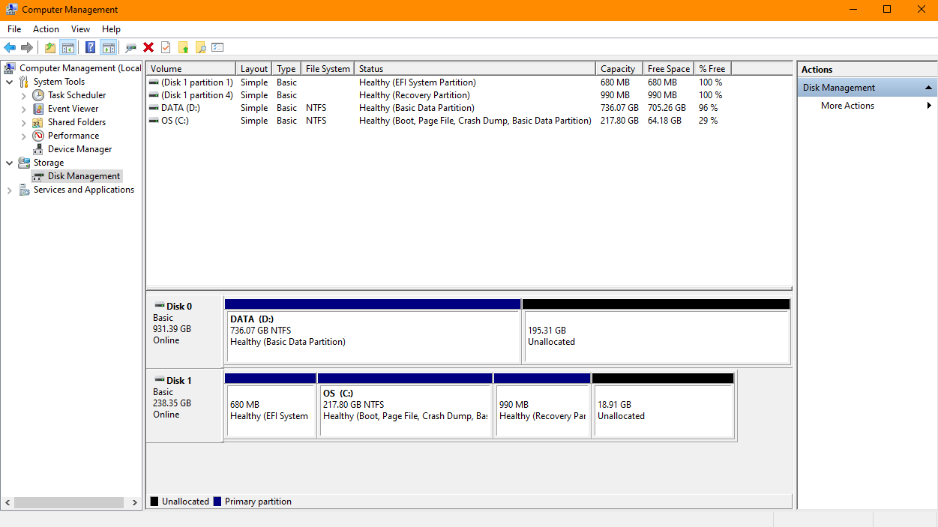
DISKPART> list partition

Partition ### Type Size Offset
------------- ---------------- ------- -------
Partition 1 Reserved 128 MB 1024 KB
Partition 2 Primary 736 GB 129 MB
--
Advanced System Settings
Start – search for Advanced system settings – Advanced – Performance – Settings – Advanced tab – Change under Virtual Memory
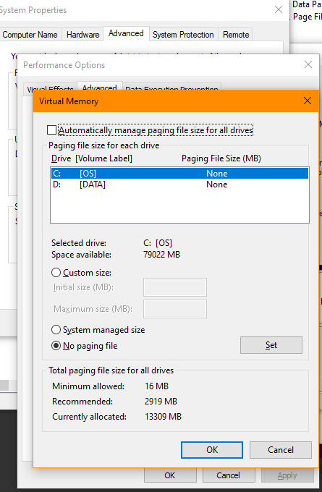

From bing:
Paging is a memory management method that enables processes to use virtual storage. A process has access to the pages it needs without waiting for them to be loaded into physical memory. The technique stores and retrieves data from a computer's secondary or virtual storage (hard drive, SSD, etc.) to the primary storage (RAM).
A paging file, also known as a swap file or virtual memory, is a reserved area on a hard disk that your PC uses as backup RAM. It allows the system to remove infrequently accessed modified data from physical memory and use physical memory more efficiently for more frequently accessed data.
Perplexity 19 Aug 24
i partitioned some space from ssd c: to ubuntu (which i called M:) and some from hdd d: to ubuntu (called L:) so windows will not try to reclaim some of that?
Answer
You're right to be concerned about Windows potentially interfering with your partitions. Based on your setup, here's what you can expect:
Windows Behavior with Partitions
- Respect for Existing Partitions: Windows generally respects existing partitions, including those used by other operating systems like Ubuntu.
- Paging File Location: When you enable automatic paging file management, Windows will primarily focus on using space on the system drive (C:) or other Windows-formatted drives.
- Non-Windows Partitions: Windows won't attempt to use or reclaim space from partitions formatted for other operating systems (like ext4 for Ubuntu) even if they're assigned drive letters in Windows.
Specific to Your Setup
- M: and L: Drives: If these are formatted with a file system Windows recognizes (like NTFS), Windows might consider them for paging file placement. However, if they're formatted with Linux file systems, Windows won't use them.
- Ubuntu Partitions: If M: and L: are your Ubuntu partitions (likely formatted as ext4), Windows won't attempt to use or modify them for paging file purposes, even if they have Windows drive letters assigned.
Recommendations
- Verify Partition Types: Ensure that M: and L: are indeed your Ubuntu partitions and not additional NTFS partitions.
- Remove Drive Letters: If M: and L: are your Ubuntu partitions, you can remove their drive letter assignments in Windows Disk Management to prevent accidental access.
- Monitor Paging File Location: After enabling automatic management, check where Windows places the paging file. It should remain on C: or D: (your Windows drives).
- Set Manual Limits: If you're still concerned, you can manually set the paging file size and location, specifying only your Windows drives.
- Regular Backups: Always maintain backups of important data from both Windows and Ubuntu partitions.
By understanding these points, you can be confident that re-enabling automatic paging file management in Windows won't interfere with your Ubuntu partitions. Windows is designed to coexist with other operating systems and respects the partitions they use.
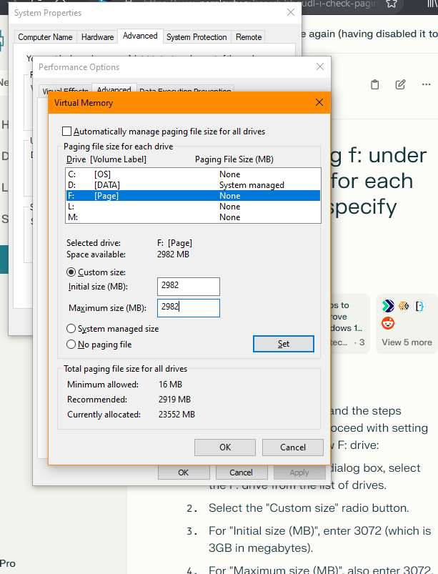
Reduced to 2977 to leave 8MB free (windows requires at least 5MB)
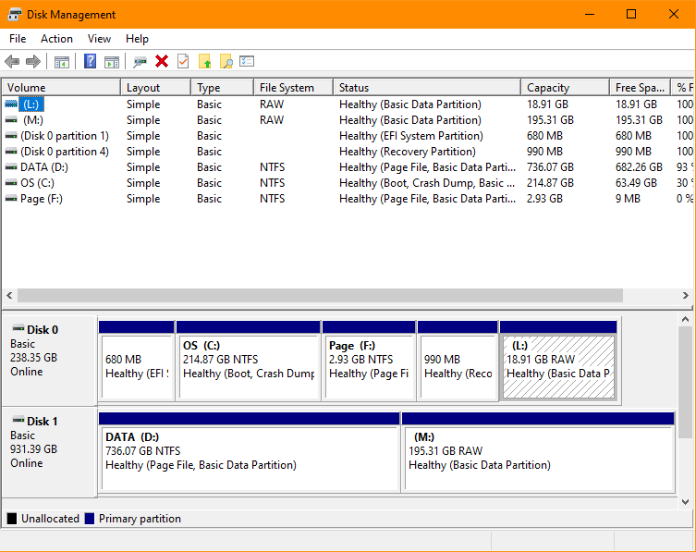
--

Reagentc
Run cmd as administrator
Microsoft Windows [Version 10.0.19045.4651]
(c) Microsoft Corporation. All rights reserved.

C:\WINDOWS\system32>reagentc / info

Configures the Windows Recovery Environment (Windows RE) and system reset.

REAGENTC.EXE <command> <arguments>

The following commands can be specified:

/info - Displays Windows RE and system reset configuration
information.
/setreimage - Sets the location of the custom Windows RE image.
/enable - Enables Windows RE.
/disable - Disables Windows RE.
/boottore - Configures the system to start Windows RE next time the
system starts up.
/setbootshelllink - Adds an entry to the Reset and Restore page in the boot
menu.

For more information about these commands and their arguments, type
REAGENTC.EXE <command> /?.

Examples:
REAGENTC.EXE /setreimage /?
REAGENTC.EXE /disable /?

C:\WINDOWS\system32>reagentc /info
Windows Recovery Environment (Windows RE) and system reset configuration
Information:

Windows RE status: Enabled
Windows RE location: \\?\GLOBALROOT\device\harddisk1\partition4\Recovery\WindowsRE
Boot Configuration Data (BCD) identifier: 708ad937-8ac7-11eb-9878-cea36af4bcd2
Recovery image location:
Recovery image index: 0
Custom image location:
Custom image index: 0

REAGENTC.EXE: Operation Successful.

Current
